Woo commerce :

Adding , deleting and updating products.
From this we can add products title, description , long description and chose the category we want to show.
Make the categories from the link Products-> Categories , the list appears in the add products page below on right side.
Woo commerce controls the ecommerce part of site which includes the menu listing , product page display , product detail page display and checkout.
The plugins used are :
Custom Post Type UI
iThemes Security
Regenerate Thumbnails
Theme My Login
Turbo links for WordPress
Useful Banner Manager
User Role Editor
Woo Commerce
WooCommerce - ShipStation Integration
Woocommerce Flipper
WooCommerce Variation Swatches and Photos
WordPress Importer
WordPress Post Tabs
WP Responsive Menu
YITH Infinite Scrolling
Ultimate TinyMCE
WP SoundCloud Ultimate
YITH WooCommerce Zoom Magnifier

On Clicking products it shows the list of products :
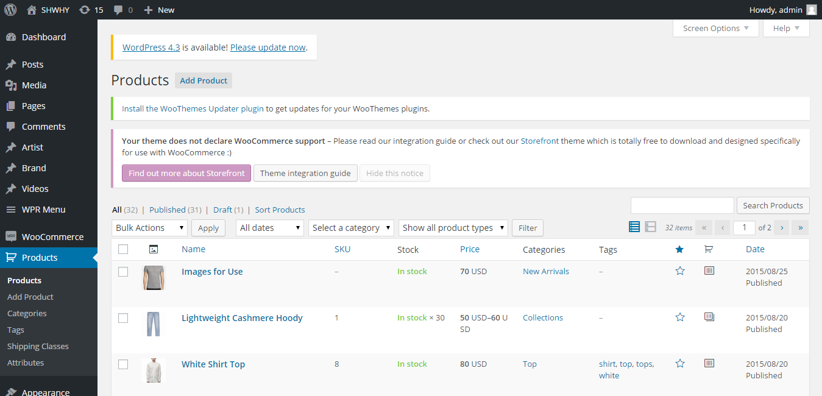

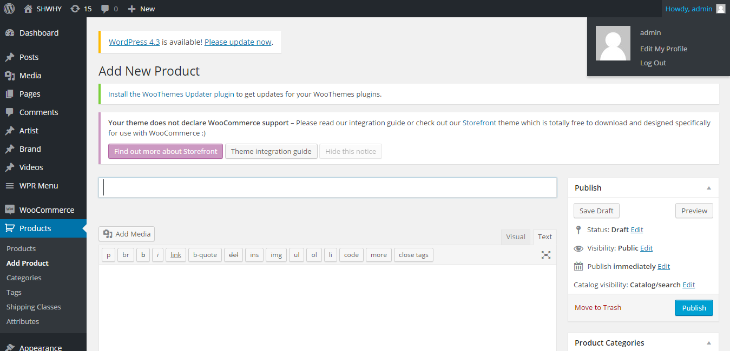

Adding products :
Add the title, description and select product data drop down to insert more product related information.
For simple products it will show without size and colour .
For variable products it will show colour and size.
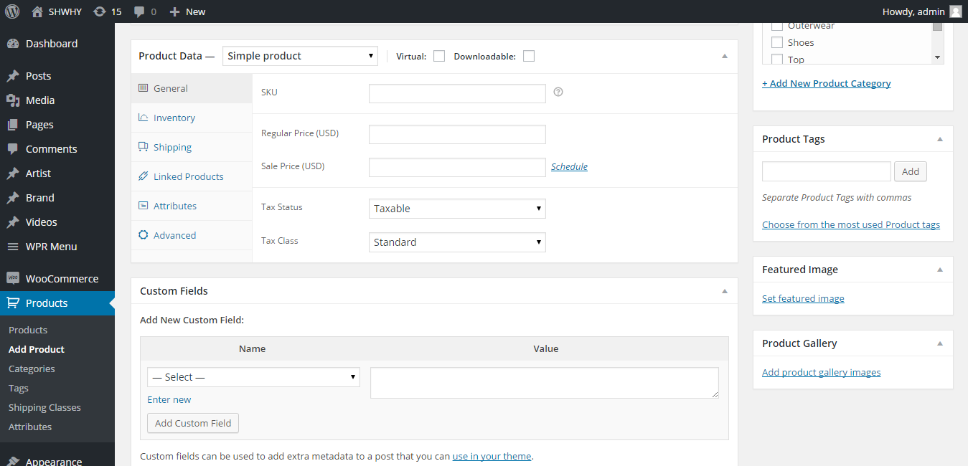

Same goes for edit product .

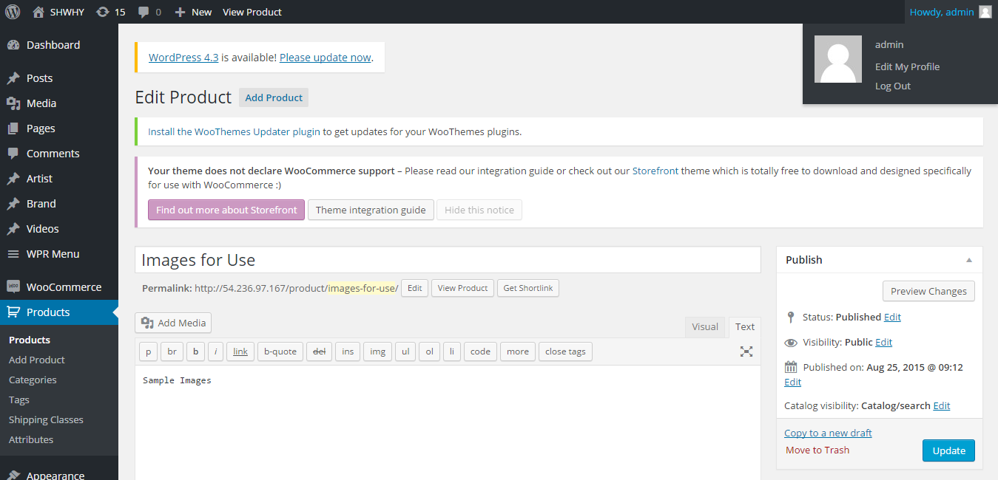

Adding product images in feature image shows in product page subsequent images in the gallery image .

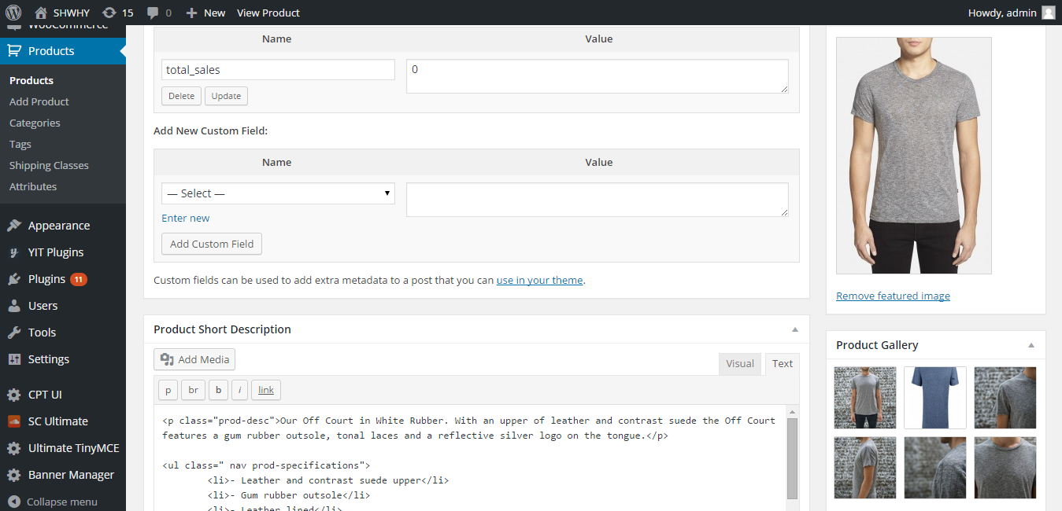

Woocommerce Settings link:

The tabs in the setings page shows the way products image, taxes , checkout , ship station integration shows.

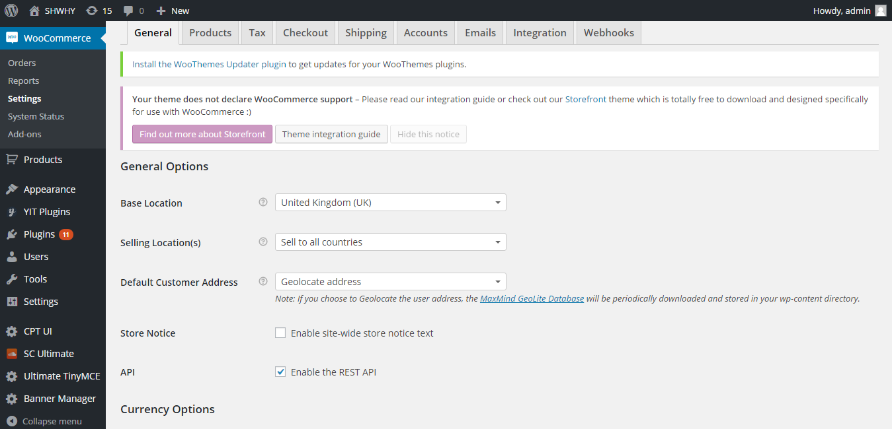

Products tabs shows the display image , inventory stock information .

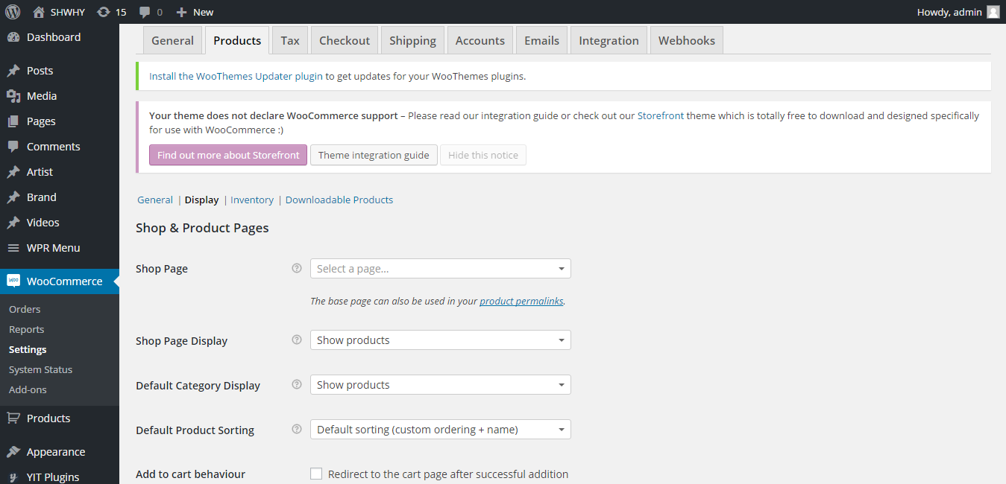

Shipping tab takes care of display, what shipping methods have to be displayed and click on save changes.

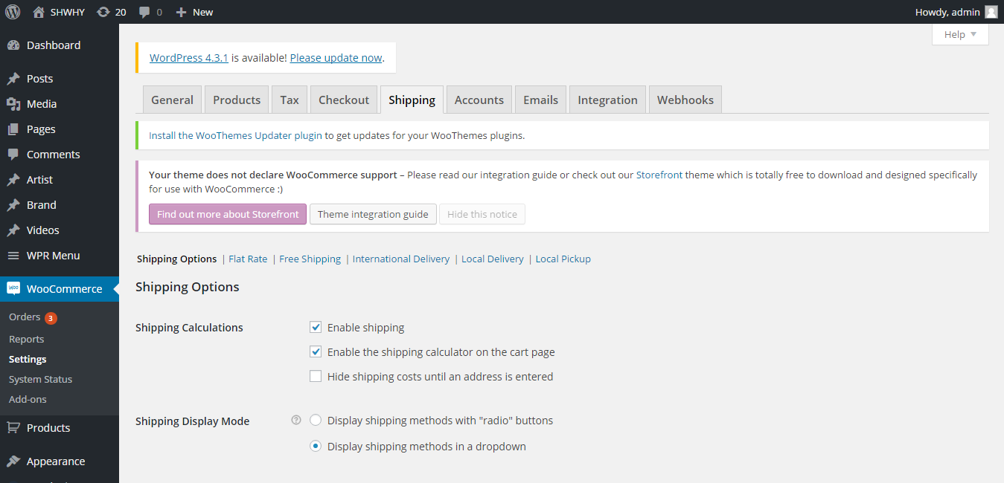

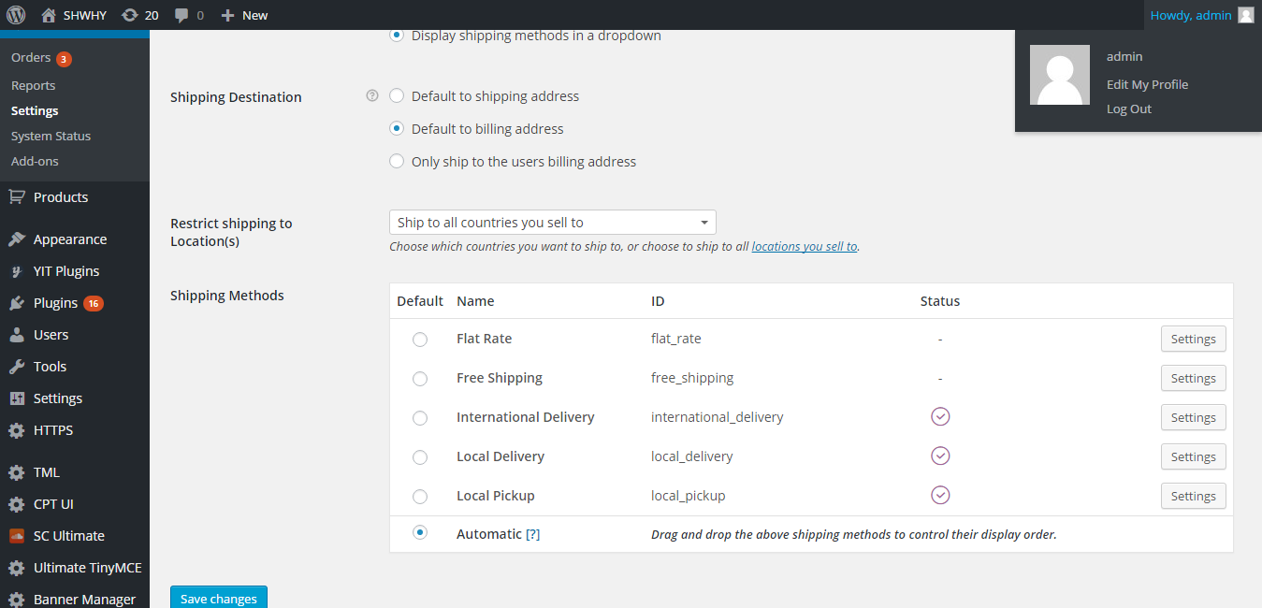

The integration tab shows the ship station integration .

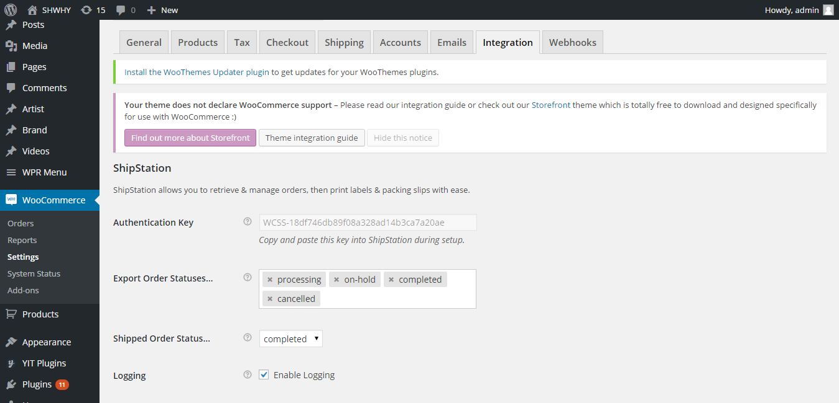

This tab shows the checkout related information as what and how to display in checkout page.

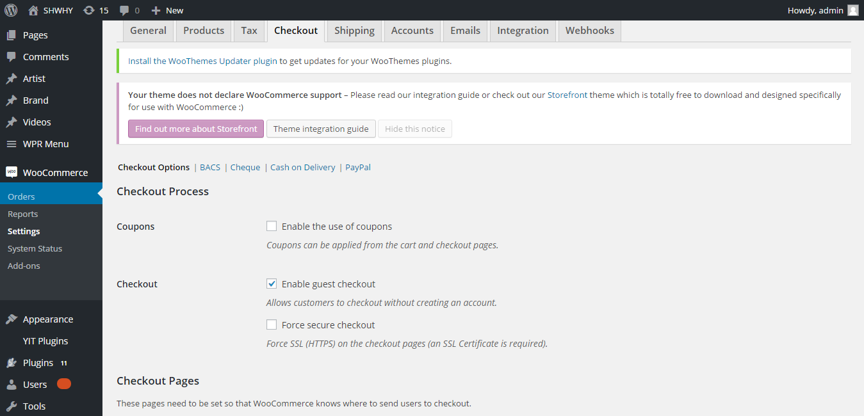

Woocommerce orders :

Shows the transaction done for the different products after payment is done.

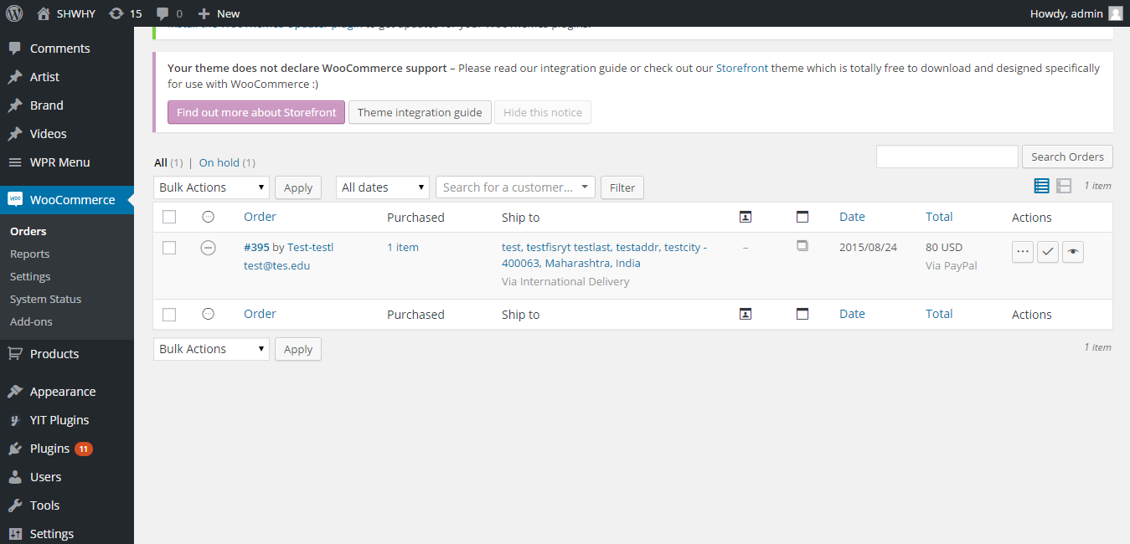

The reports shows all the transaction of products .

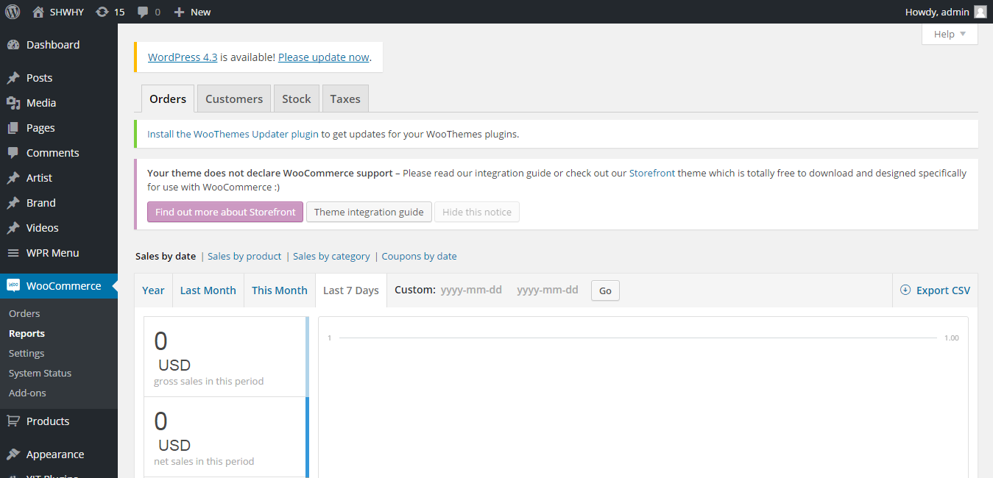

Theme Updation:

From Appearance link on left side menu:

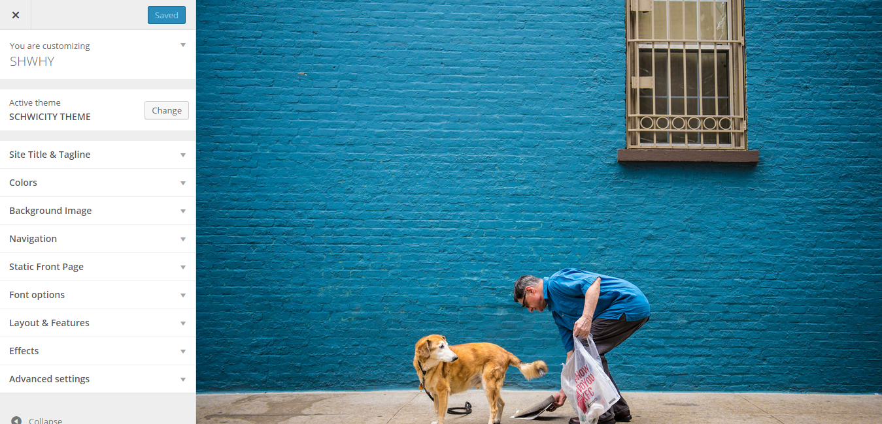
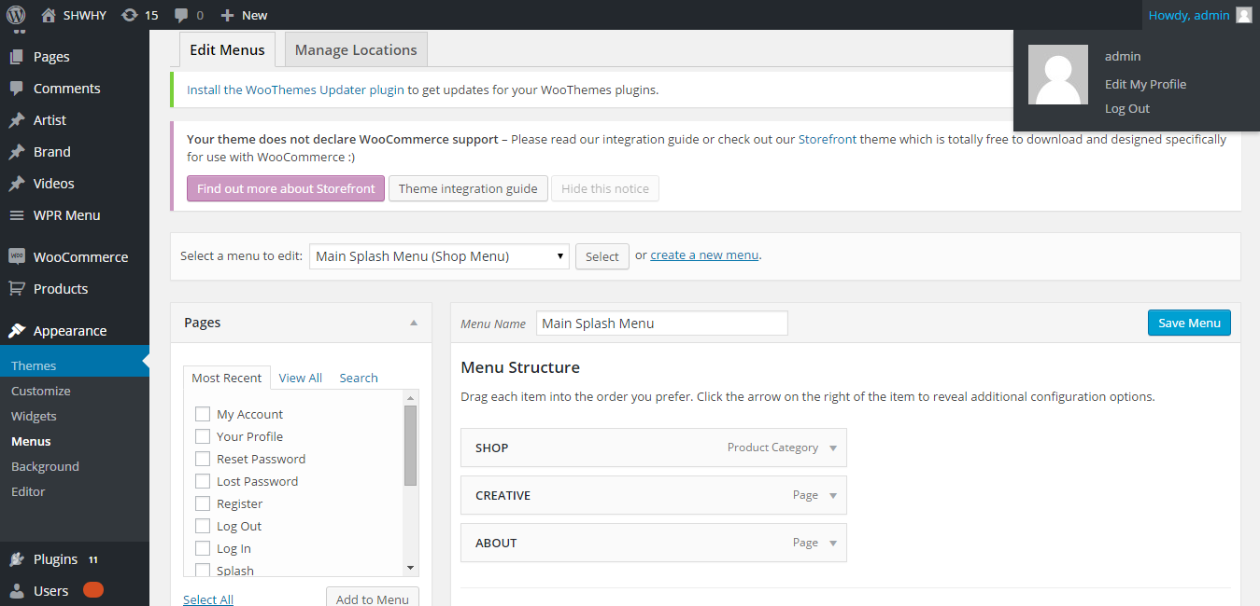

We can rearrange the menus by moving up/down and save it using Save Menu button , the result will be visible in front end.

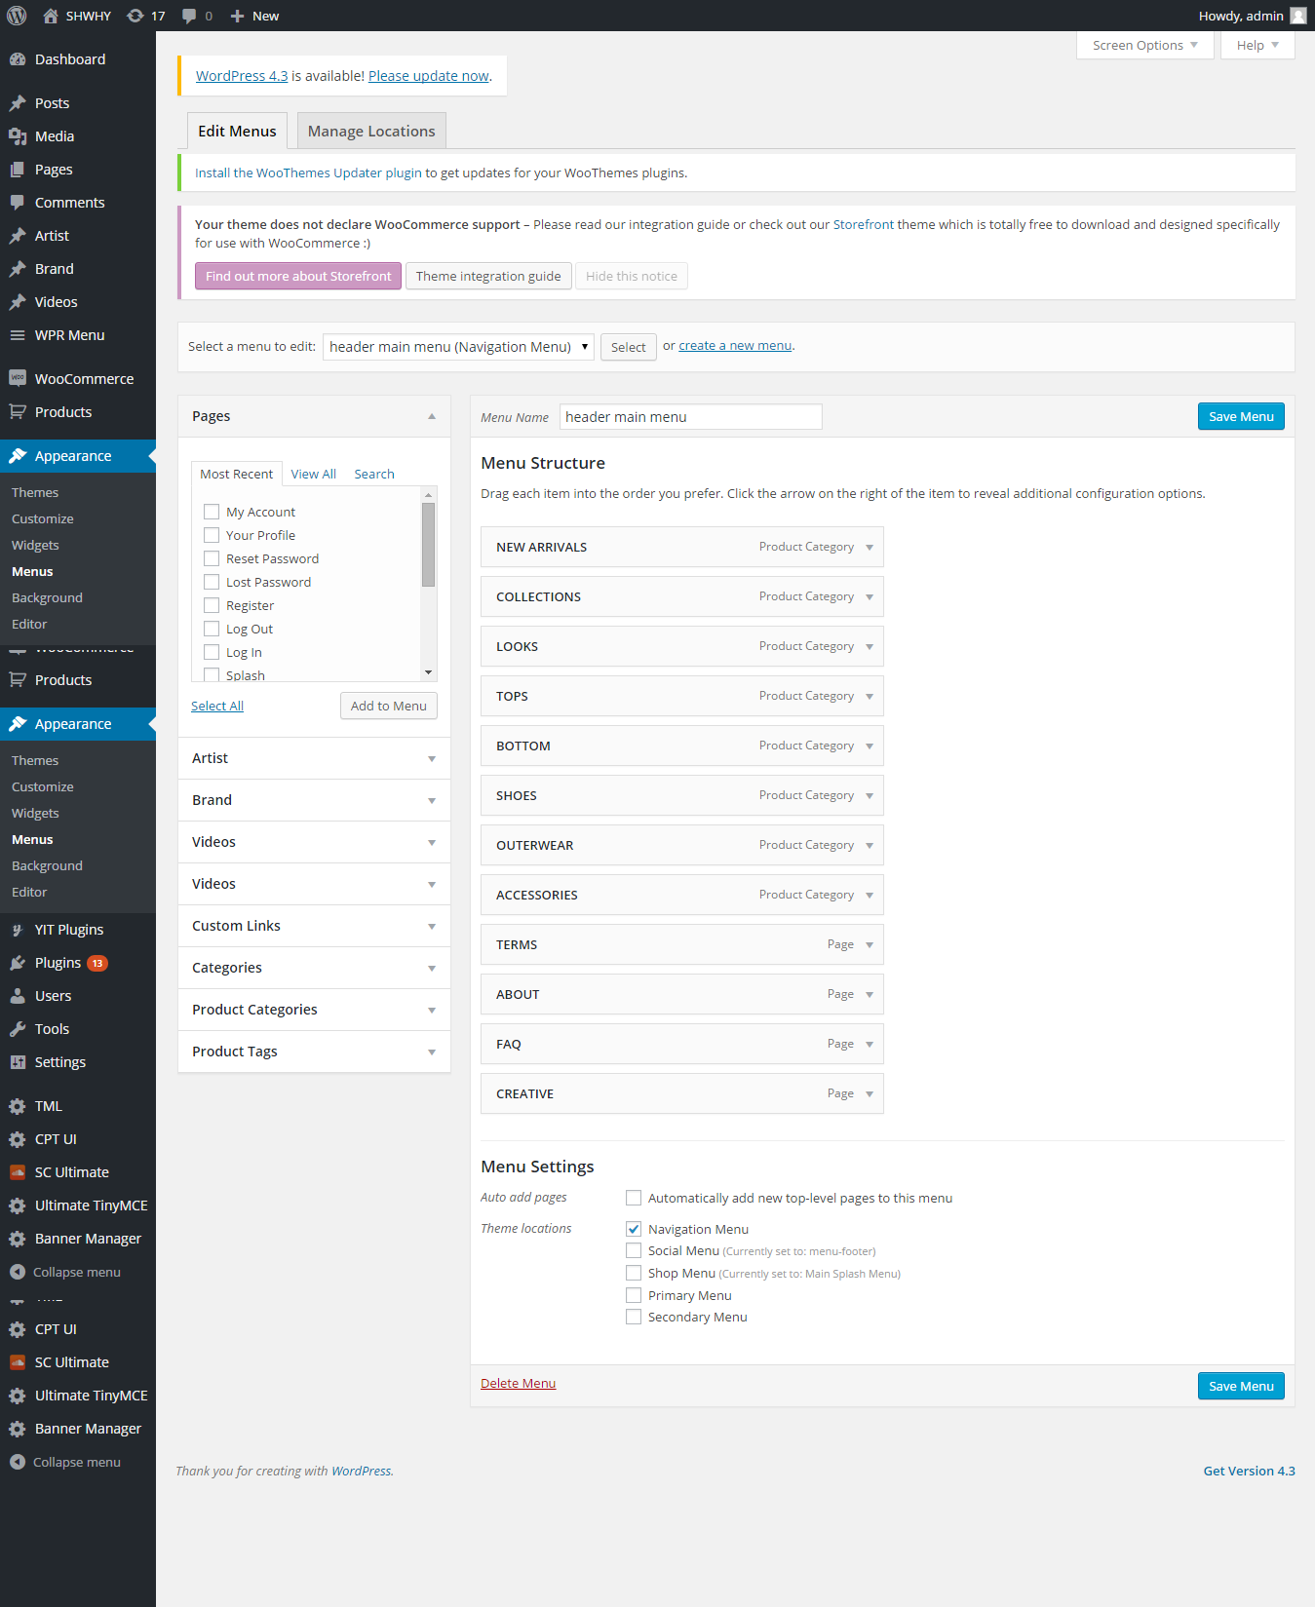

The login page is controlled by this plugin which overrides the login page of wordpress .We can control the redirect , email , links , captcha , security and profiles.

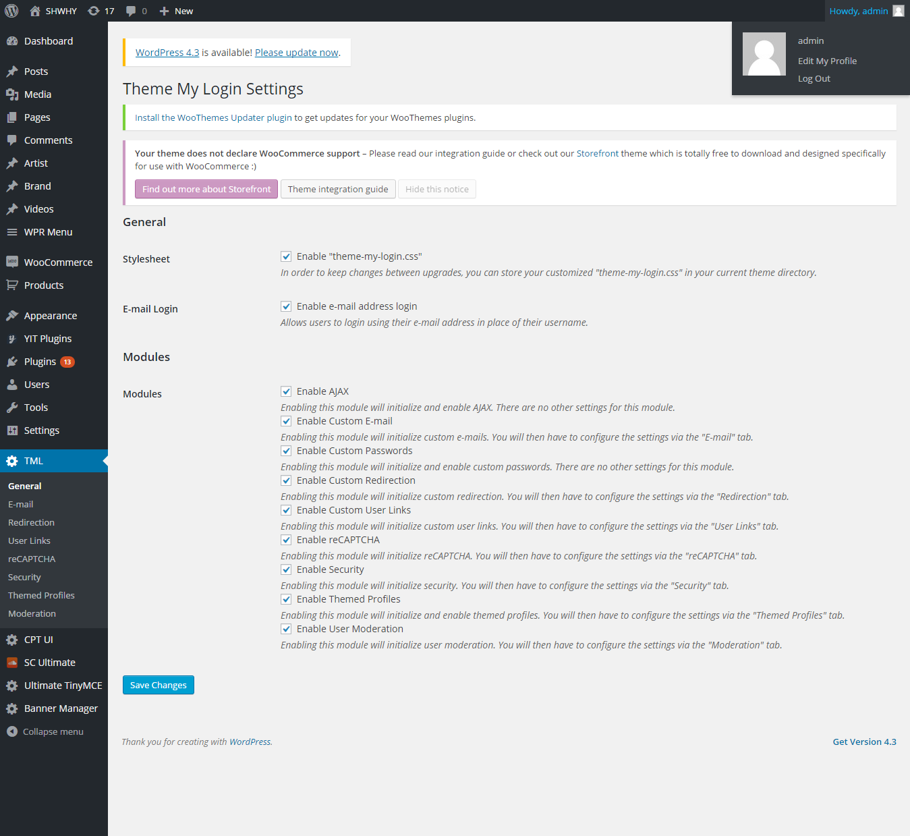

The sound cloud ultimate plug-in is used with sound cloud to show the playlist in frontend. We can upload, add, delete, preview and edit the songs and playlists.

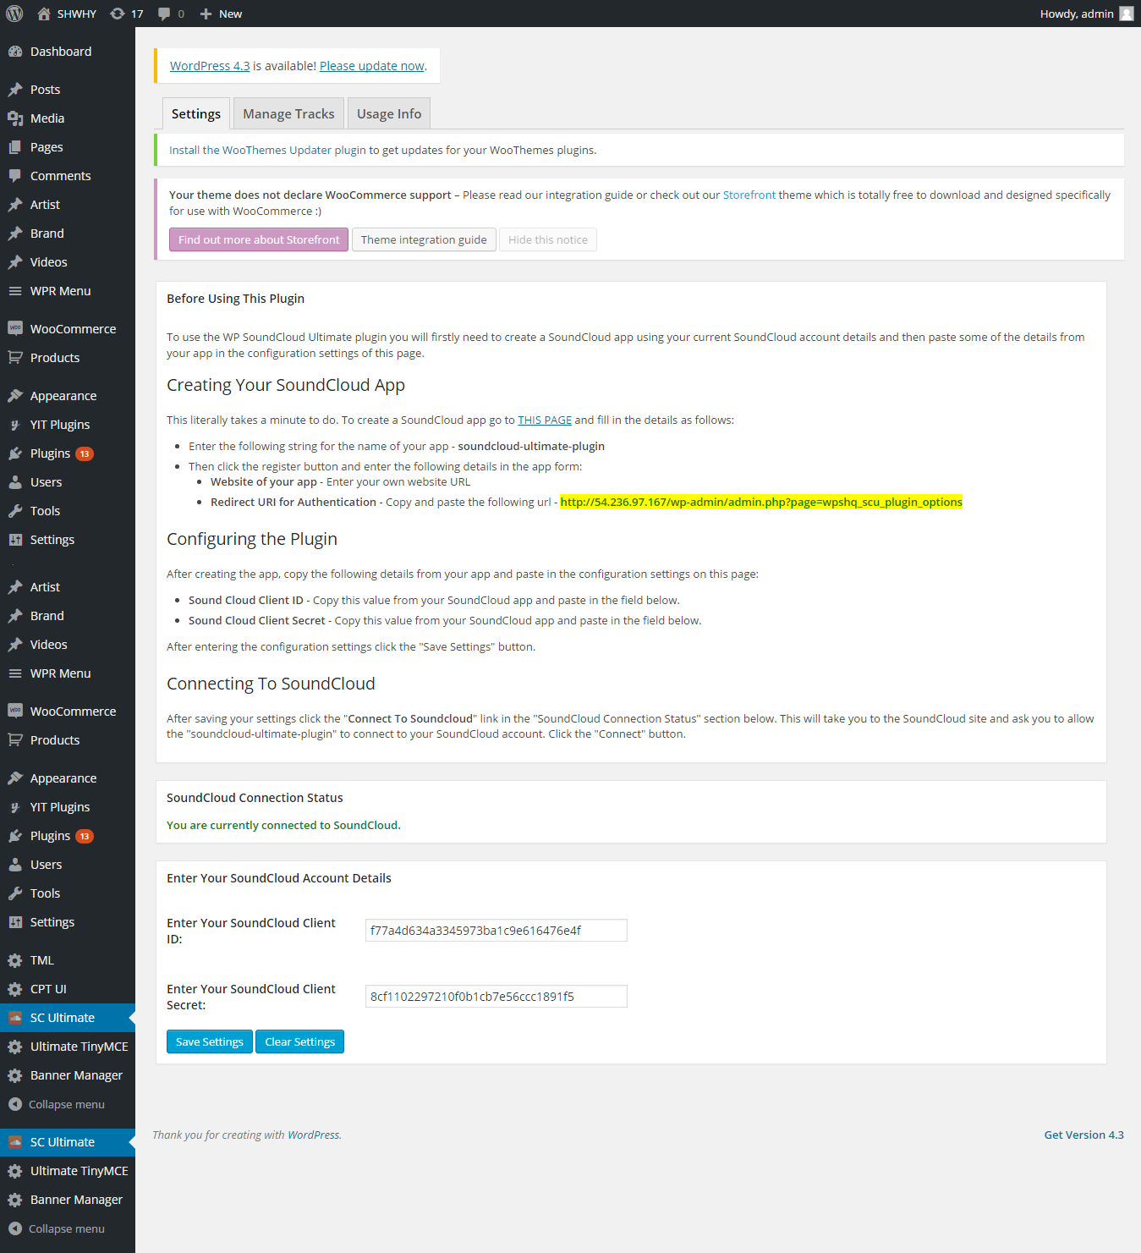

When we select playlists from dropdown mentioned “Your SoundCloud Tracks” , it shows all playlist from the soundcloud account. Please select only marked as “public” like “Playlist: shwhy-sound-waves-volume-005 - public” because private playlists will not be displayed in front end because of authentication issue.

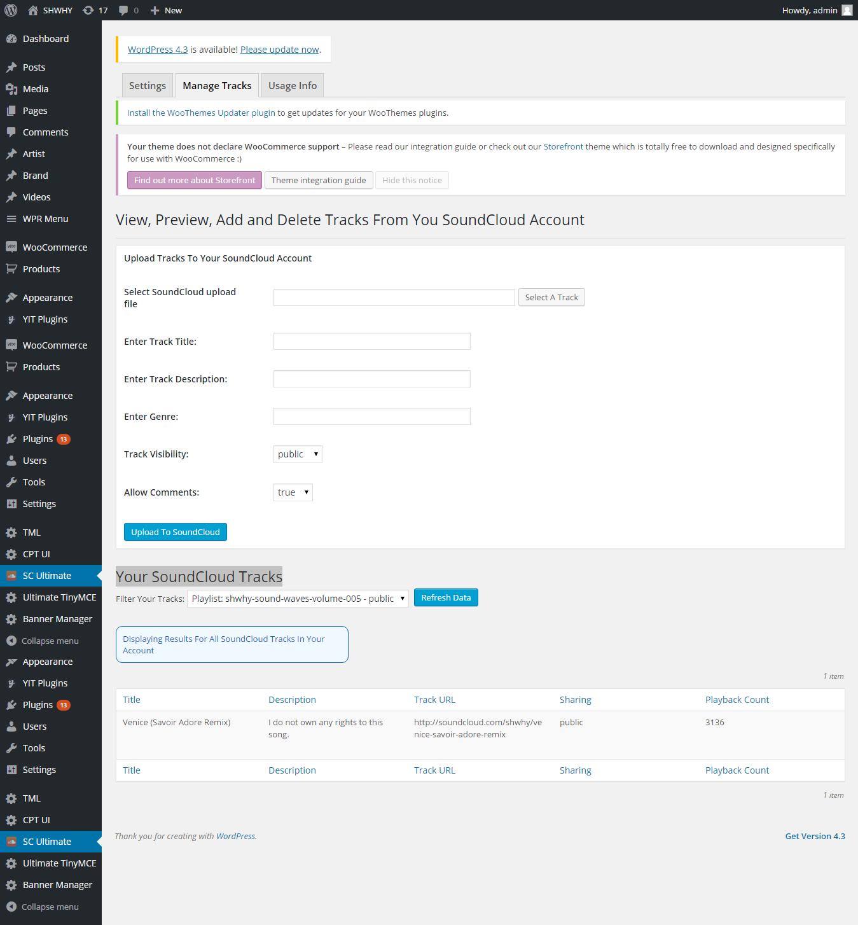

Adding , editing pages:

Have added different pages in the Pages link in wordpress admin section.Suppose want to edit the “About “ page link , just click and edit it in visual editor or in text editor , text editor wouldn’t have the visual toolbar .

Stripe integration with Twitter

This facility makes direct payment from twitter account using stripe payment gateway.
Logii with the username /password to stripe and twitter.
Go to dashboard , click on products link .
One sample product is added in both test and live environment.
To Add another product just , click on the +New Product link at the top right , Add details like description, title etc , then add the image url from our side .
Twitter will automatically make the website url encrypted to their own form.
The tweet URL will not be formed in test mode but it automatically shows in live URL .
The Image URL shows like this http://54.236.97.167/black-shorts
For e.g https://products.stripe.com/twitter/acct_15mOkVJFjT5nqN1g/products/prod_731aCWbf5vQnMS.

Paste the above link in the account , the details with image along with buy now button will be visible for the users , where in users will click on buy now and twitter with stripe make payment and shoots mail to each side .
The amount is directly deposited in the account.

