Woo commerce :

Adding , deleting and updating products.
From this we can add products title, description , long description and chose the category we want to show.
Make the categories from the link Products-> Categories , the list appears in the add products page below on right side.
Woo commerce controls the ecommerce part of site which includes the menu listing , product page display , product detail page display and checkout.
The plugins used are :
Custom Post Type UI
iThemes Security
Regenerate Thumbnails
Theme My Login
Turbo links for WordPress
Useful Banner Manager
User Role Editor
Woo Commerce
WooCommerce - ShipStation Integration
Woocommerce Flipper
WooCommerce Variation Swatches and Photos
WordPress Importer
WordPress Post Tabs
WP Responsive Menu
YITH Infinite Scrolling
Ultimate TinyMCE
WP SoundCloud Ultimate
YITH WooCommerce Zoom Magnifier

On Clicking products it shows the list of products :
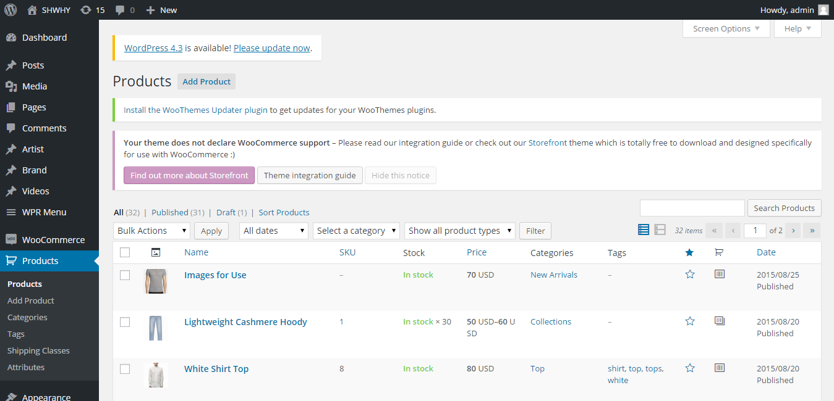

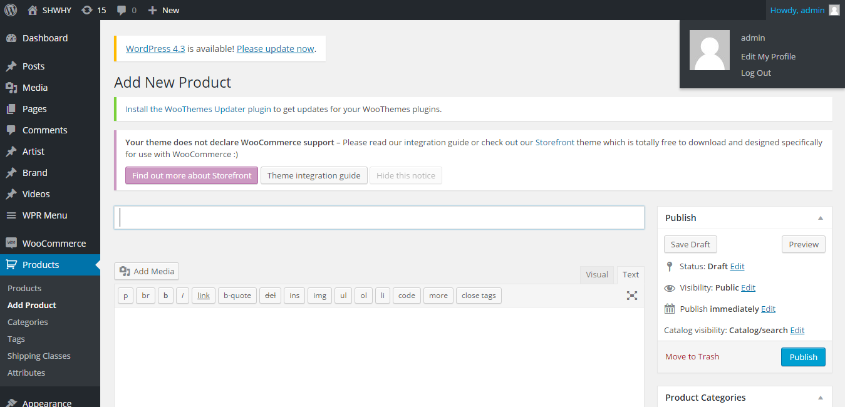

Adding products :
Add the title, description and select product data drop down to insert more product related information.
For simple products it will show without size and colour .
For variable products it will show colour and size.
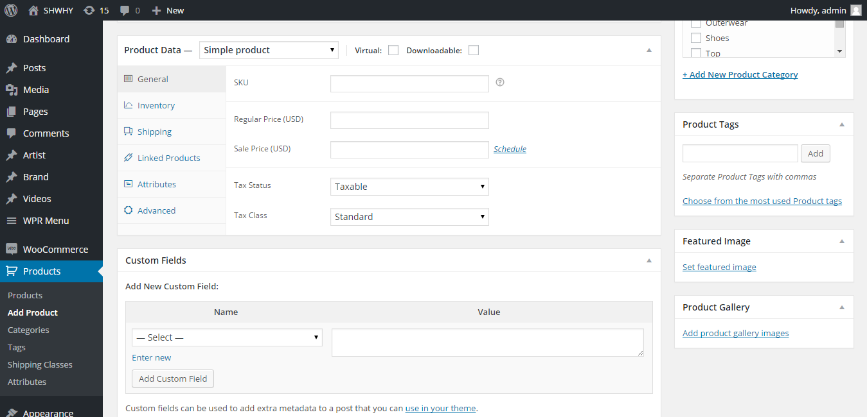

Same goes for edit product .

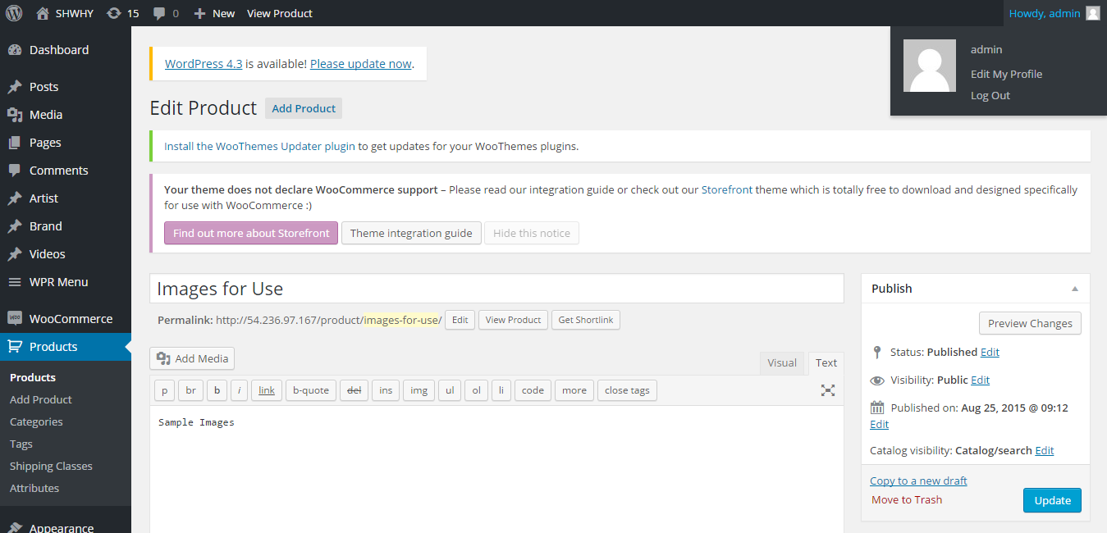

Adding product images in feature image shows in product page subsequent images in the gallery image .

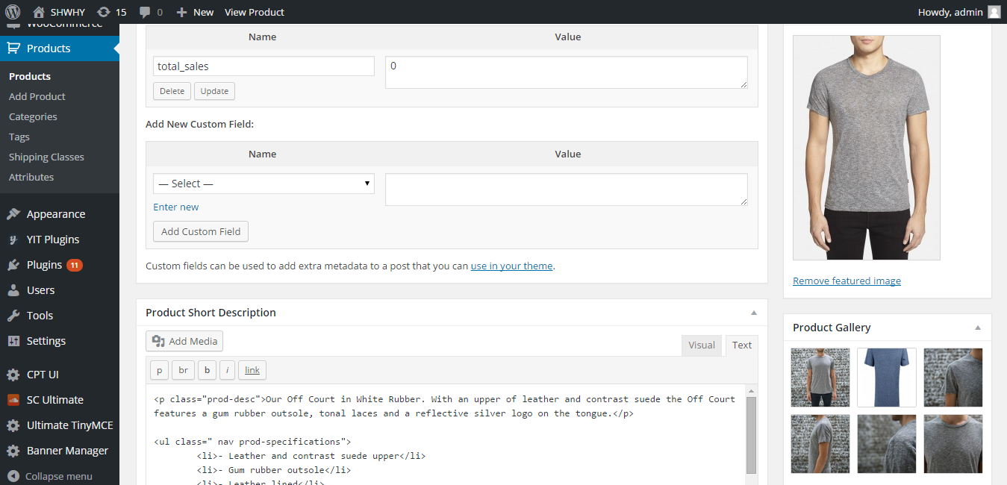

Woocommerce Settings link:

The tabs in the setings page shows the way products image, taxes , checkout , ship station integration shows.

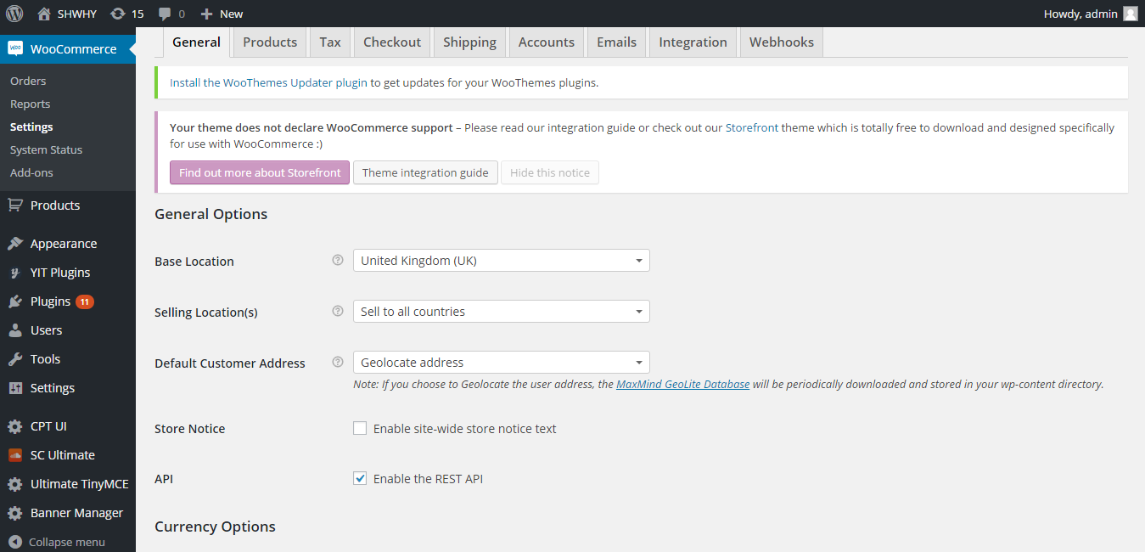

Products tabs shows the display image , inventory stock information .

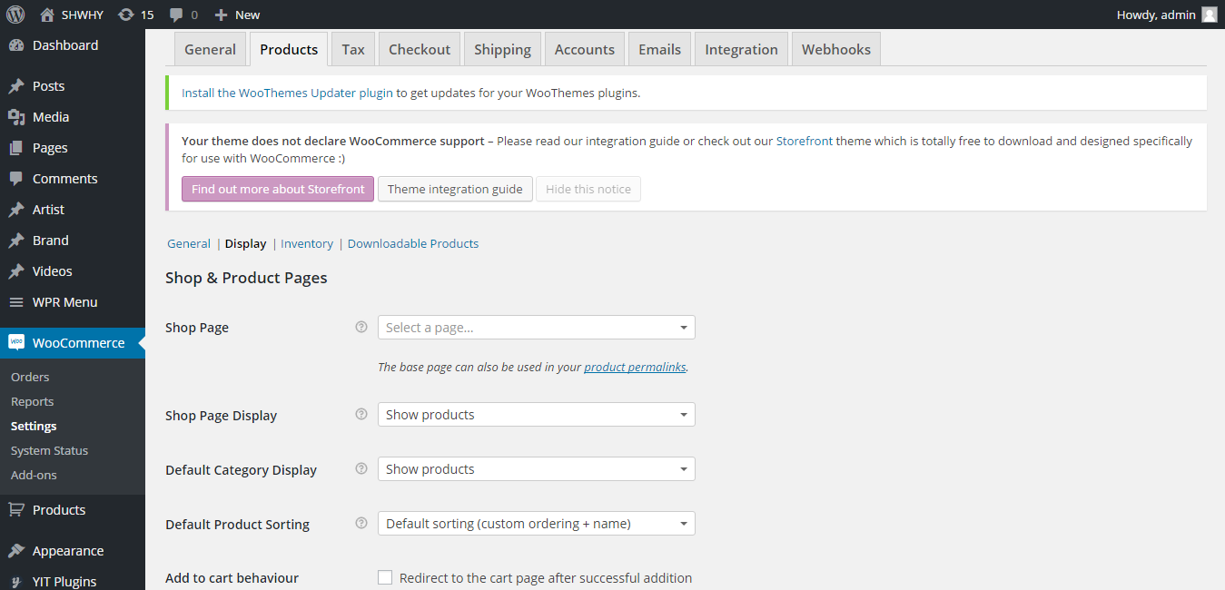

The integration tab shows the ship station integration .

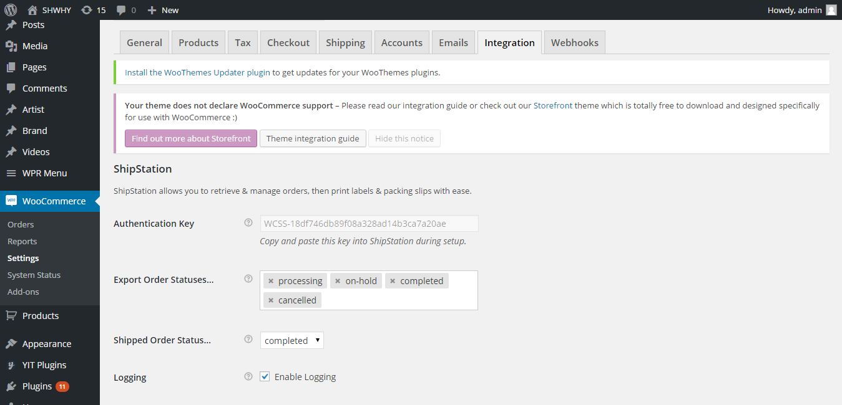

This tab shows the checkout related information as what and how to display in checkout page.

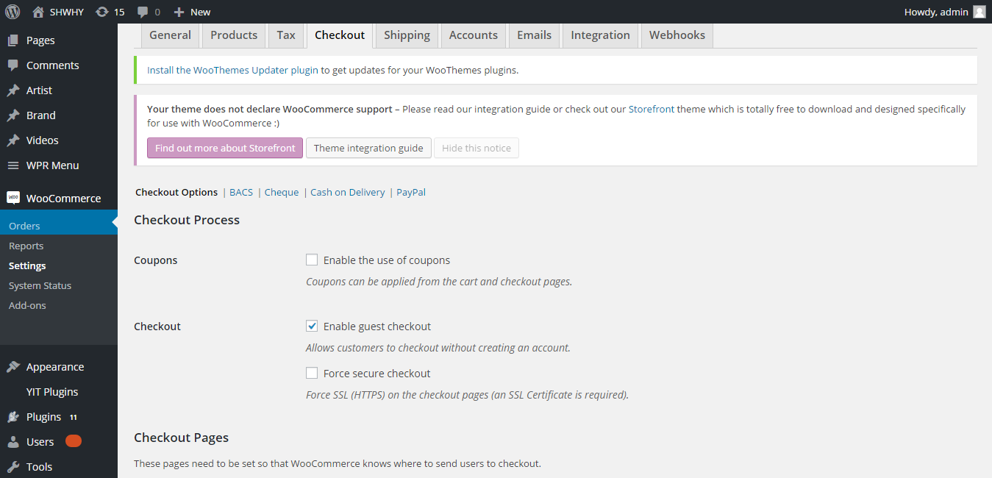

Woocommerce orders :

Shows the transaction done for the different products after payment is done.

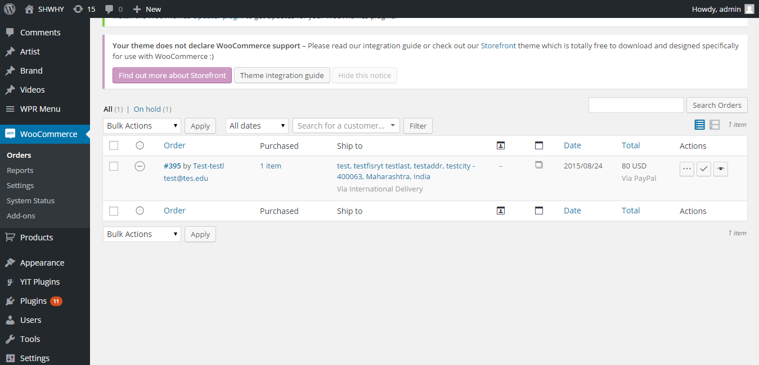

The reports shows all the transaction of products .

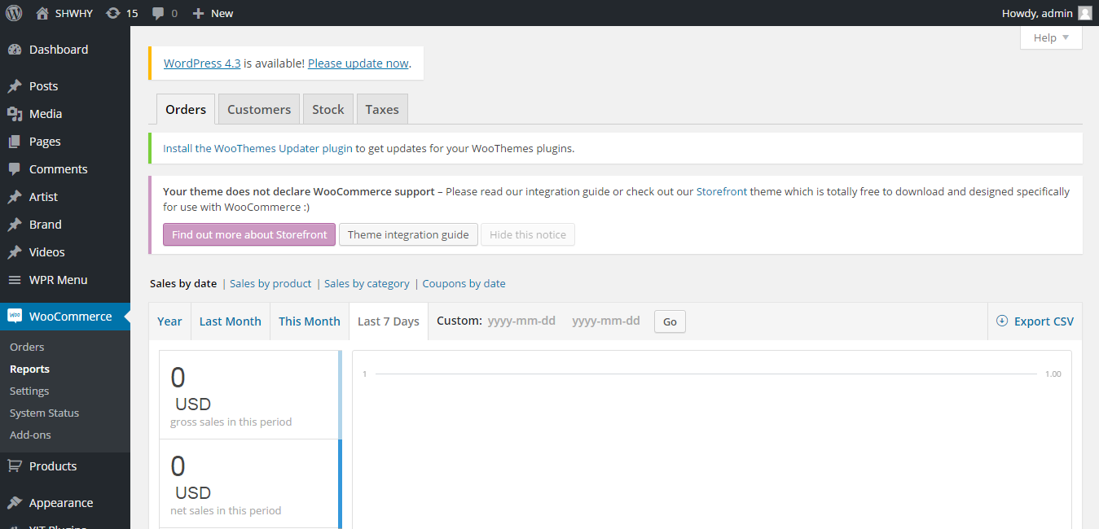

Theme Updation:

From Appearance link on left side menu:

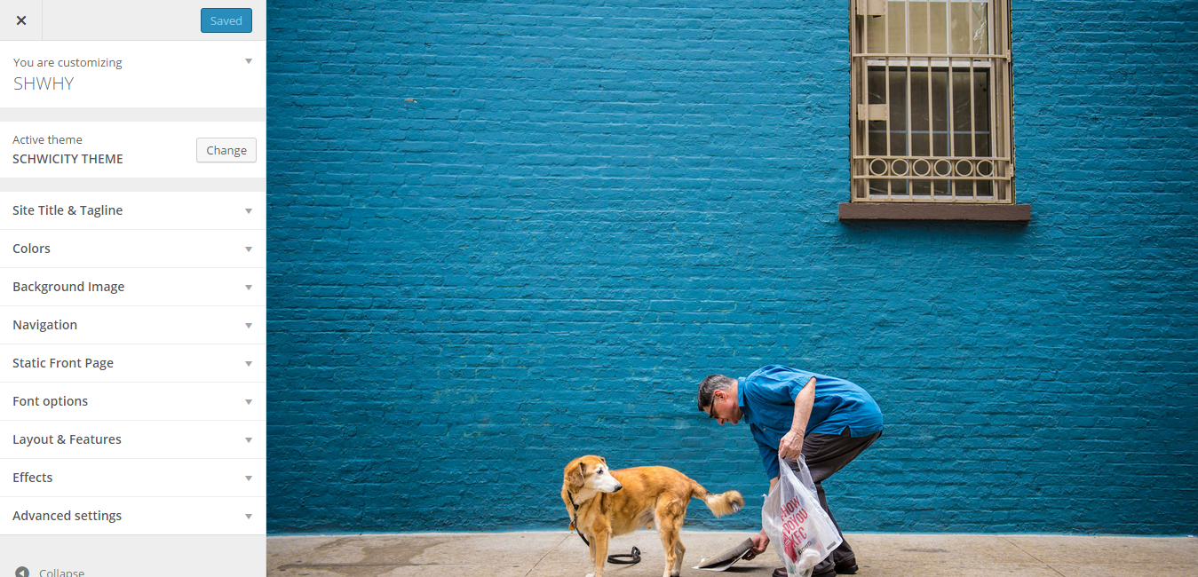
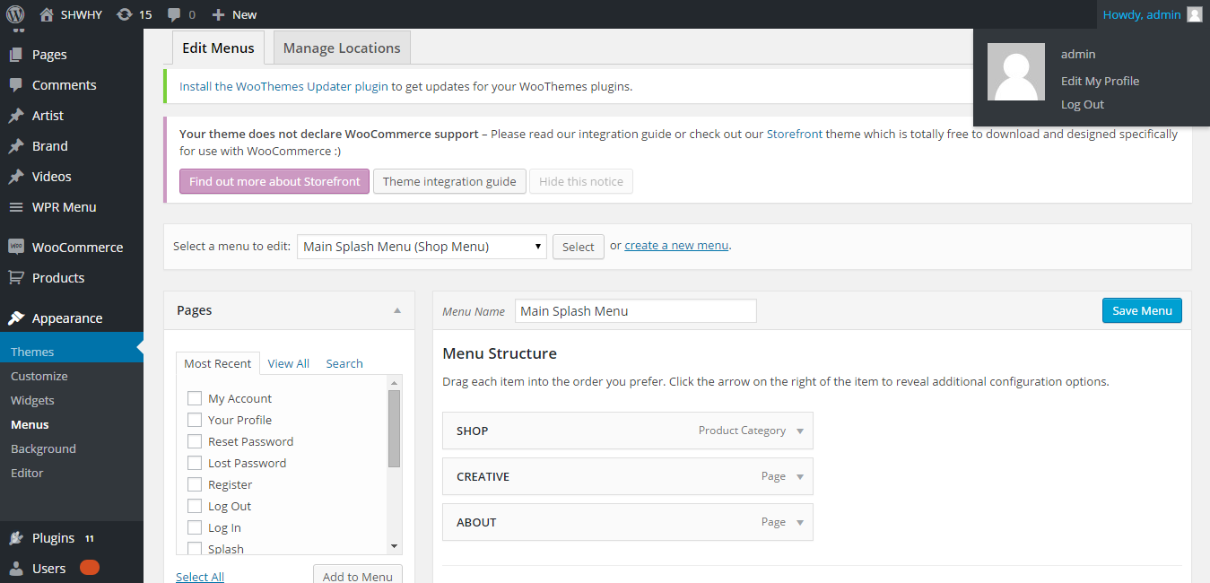

We can rearrange the menus by moving up/down and save it using Save Menu button , the result will be visible in front end.

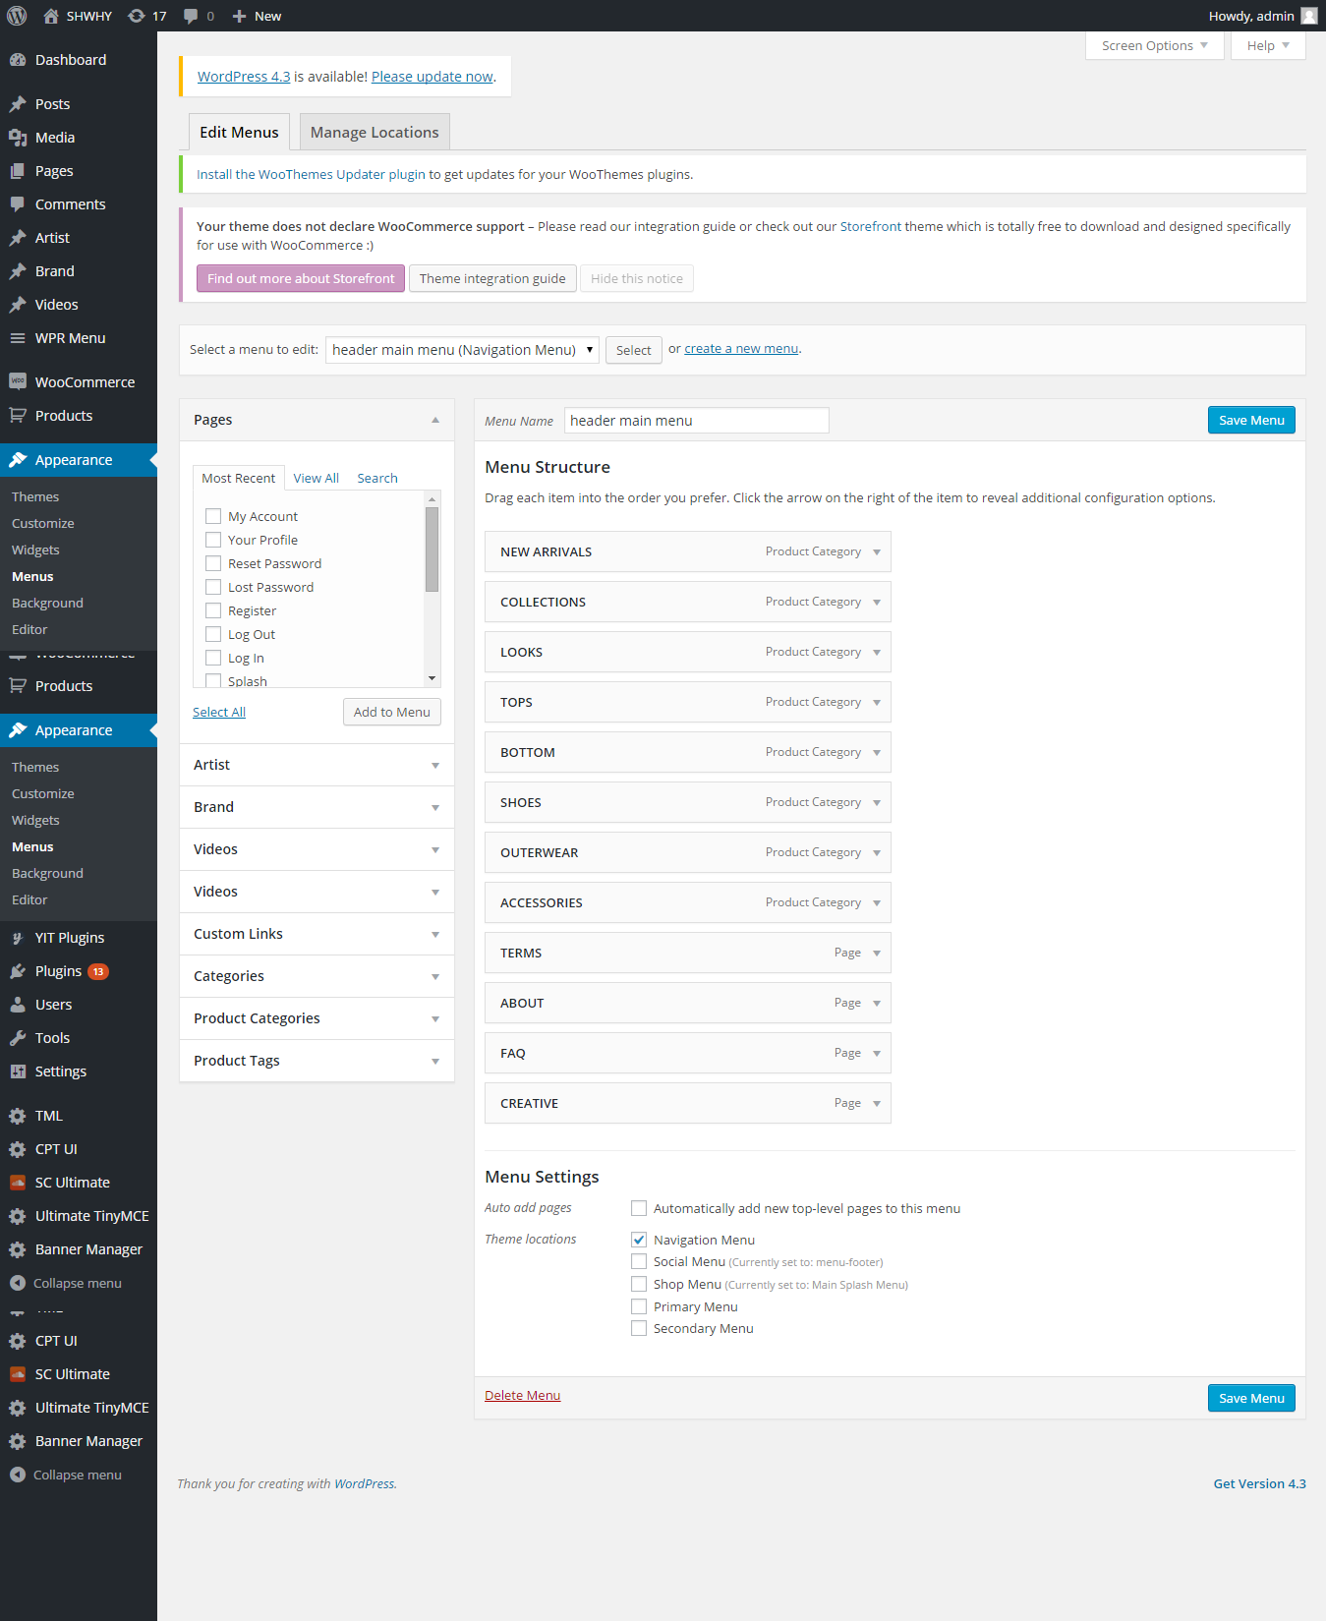

The login page is controlled by this plugin which overrides the login page of wordpress .We can control the redirect , email , links , captcha , security and profiles.

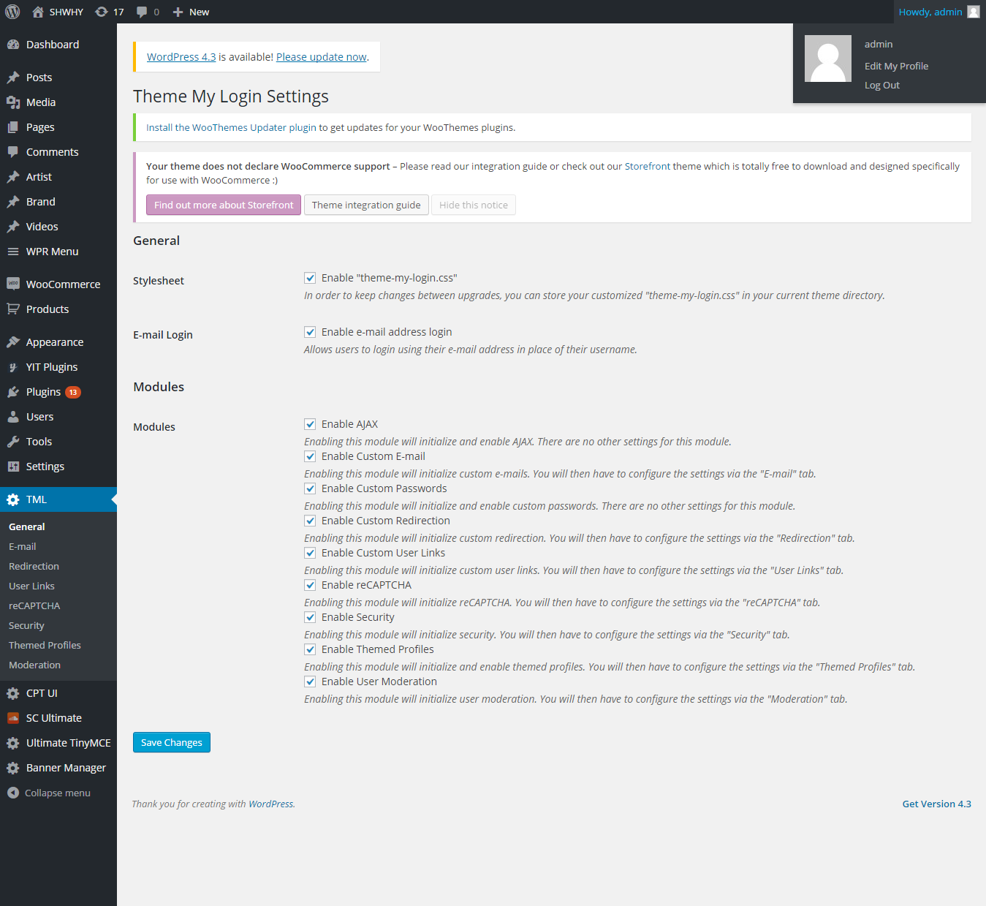

The sound cloud ultimate plug-in is used with sound cloud to show the playlist in frontend. We can upload, add, delete, preview and edit the songs and playlists.

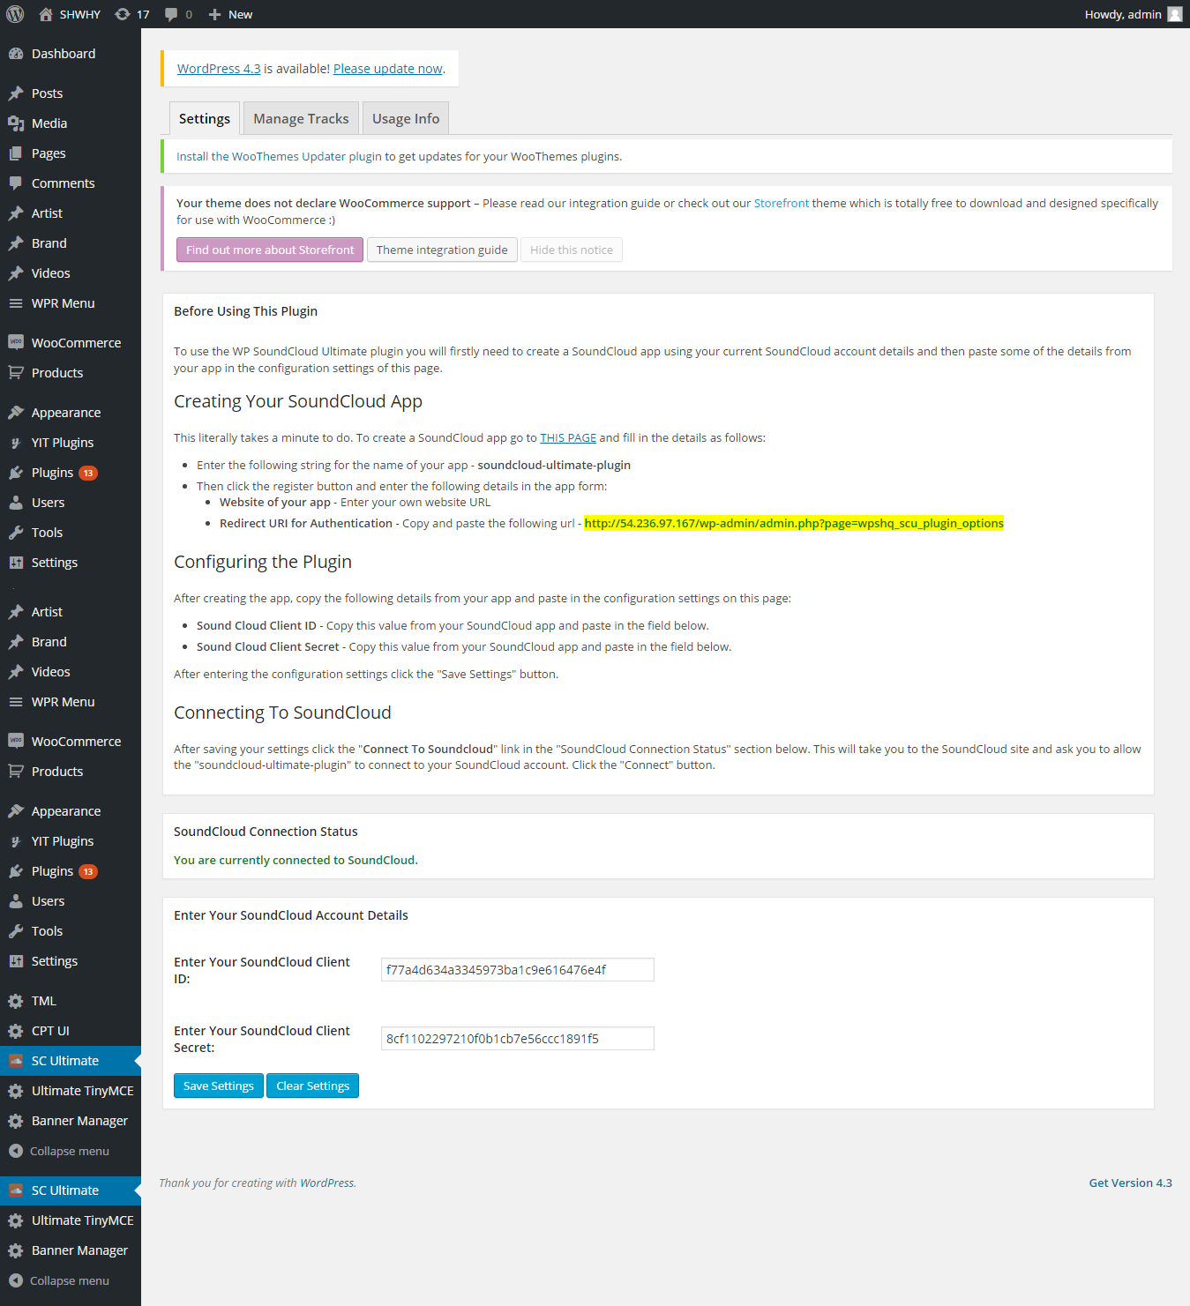

When we select playlists from dropdown mentioned “Your SoundCloud Tracks” , it shows all playlist from the soundcloud account. Please select only marked as “public” like “Playlist: shwhy-sound-waves-volume-005 - public” because private playlists will not be displayed in front end because of authentication issue.

