Woocommerce :

Adding , deleting and updating products.
From this we can add producst title, description , long description and chose the category we want to show.
Make the categories from the link Products->Catgeories , the list appears in the add products page below on right side.
Woocommerce controls the ecommerce part of site which includes the menu lisitng , product page display , product detail page display and checkout.
The plugins used are
Custom Post Type UI
iThemes Security
Regenerate Thumbnails
Theme My Login
Turbolinks for WordPress
Useful Banner Manager
User Role Editor
WooCommerce
WooCommerce - ShipStation Integration
Woocommerce Flipper
WooCommerce Variation Swatches and Photos
WordPress Importer
WordPress Post Tabs
WP Responsive Menu
YITH Infinite Scrolling
YITH WooCommerce Zoom Magnifier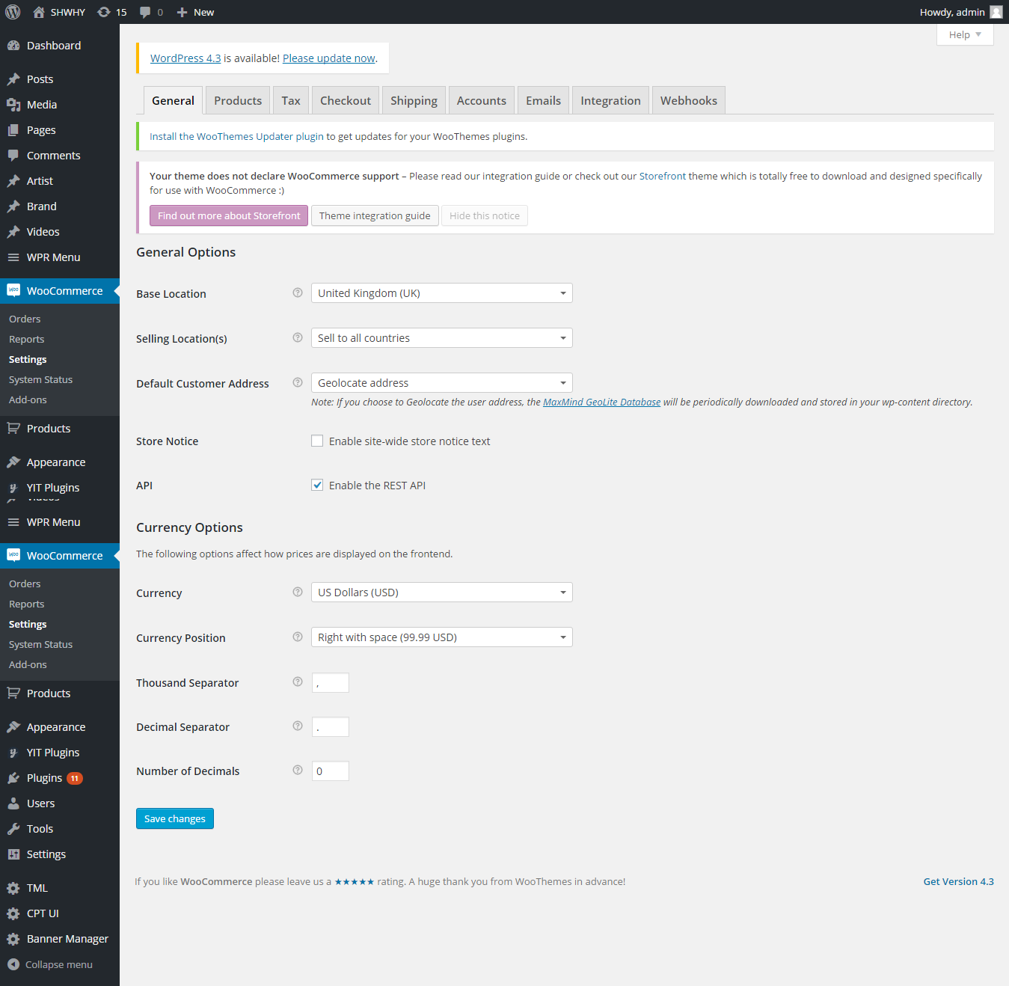

- 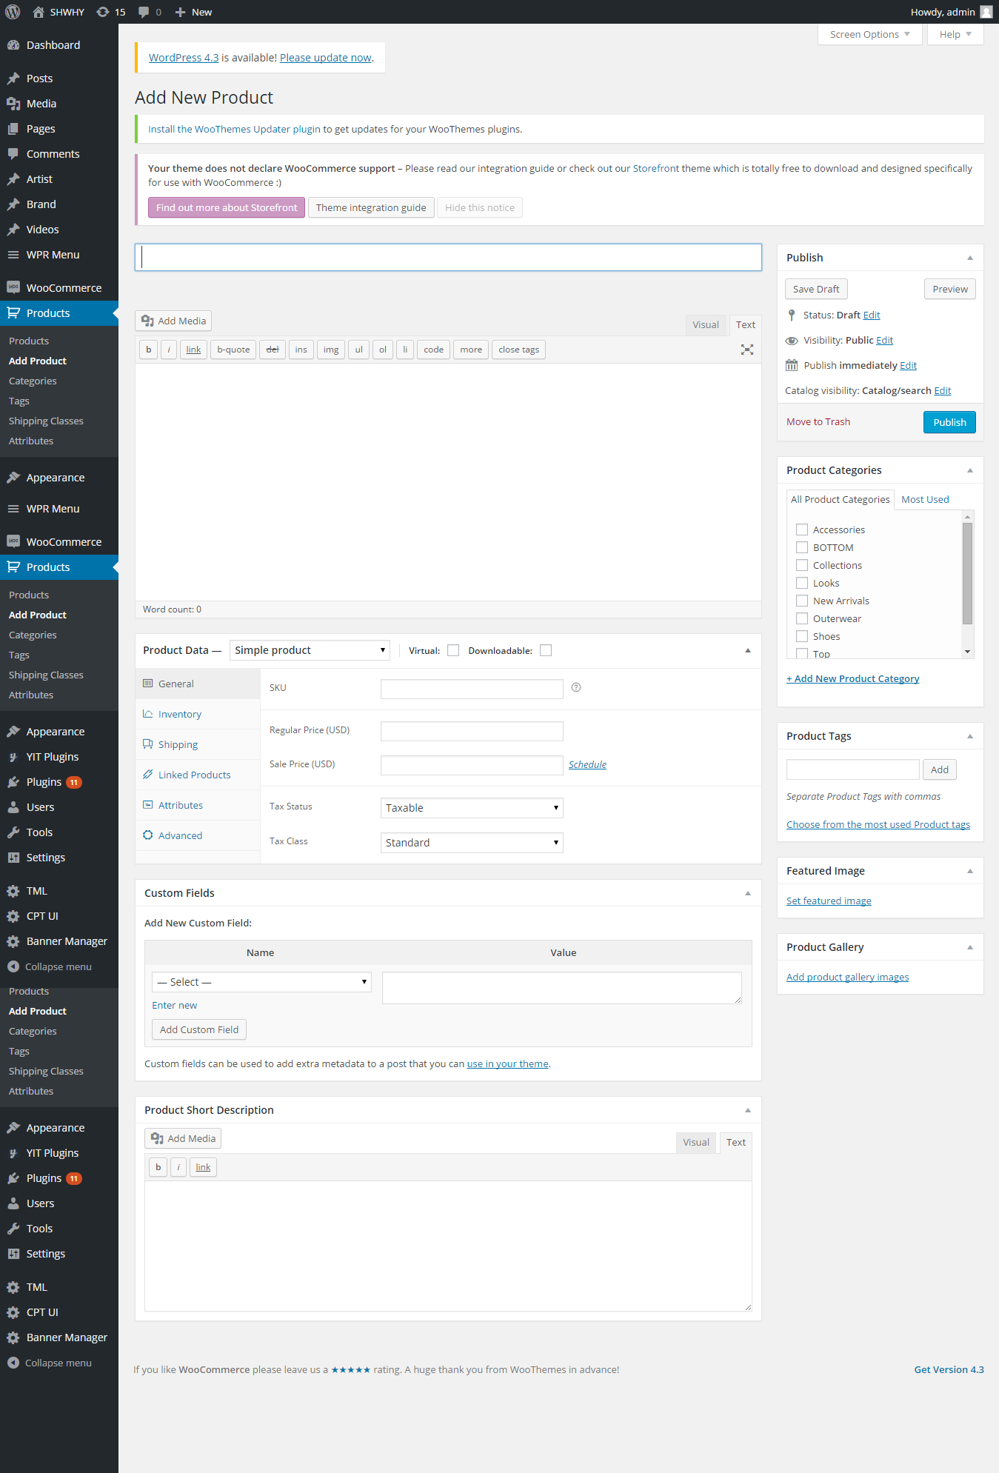

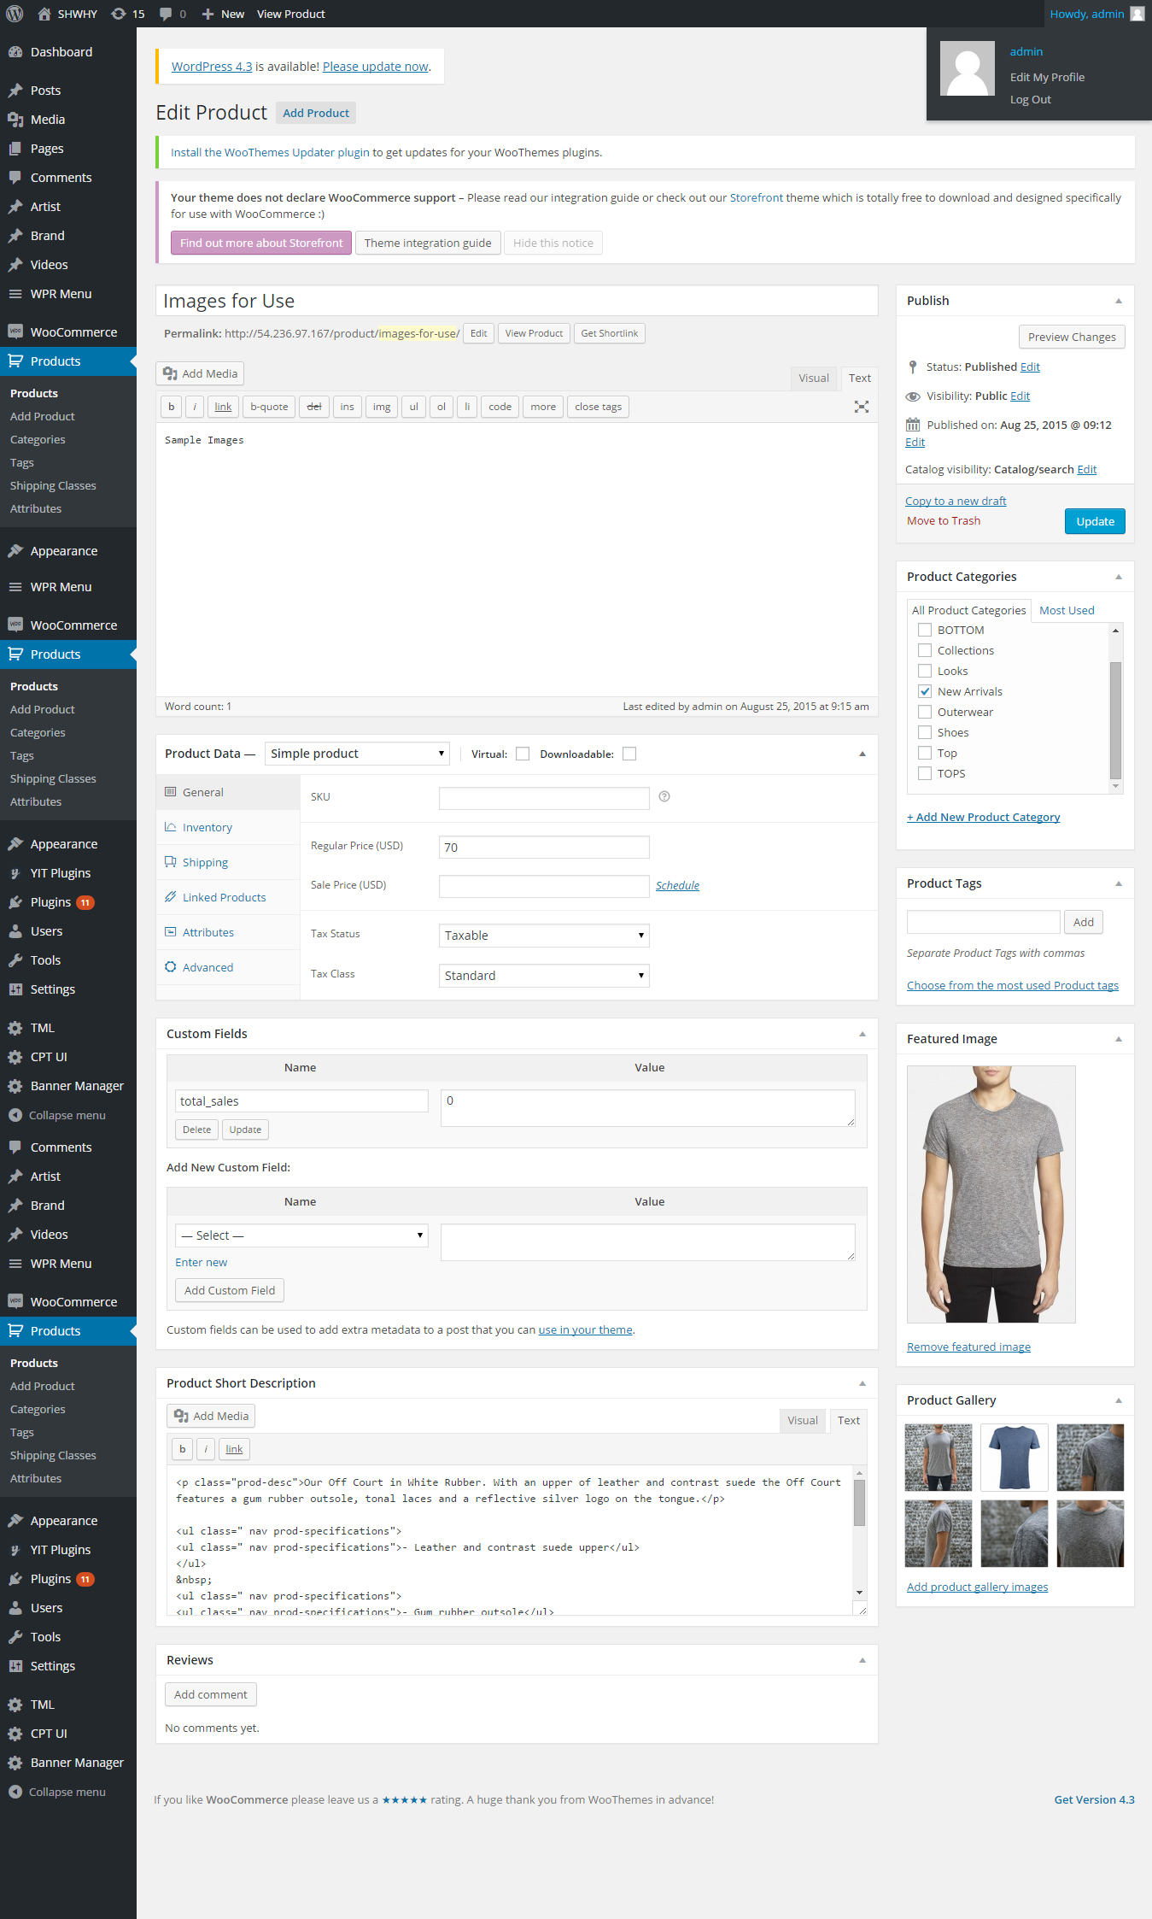
Adding product images in feature image shows in product page subsequent images in the gallery image .

